|  |
| --- |
|  |
| Simulator Testing Tool |
| For ACI Applications |
|  |

|  |
| --- |
|  |

**EFT Technologies – 2013**

Table of Contents

Overview of Simulator Processes and Functions 4

Brief overview 4

Process Flow 5

Simulator UI 6

Main Menu Page Functions 6

Administrative Functions: 7

Entities Functions: 8

Messages Functions: 9

Acks Functions 10

Results Functions 11

Browser: 12

Administrative Functions 13

Environment 13

Events 14

Swift Statistics 15

Chips Control 16

Video Control 17

Video Statistics 18

Housekeeping Functions 19

MDR & RGW Maintenance 20

Entities 21

Processes 21

Feeders 22

Links 23

Queues 24

Messages 25

Splitter 25

Loader 26

Required fields 26

RGW Loader Control 28

Acks 29

AckRuleTable Control 29

Ack/Receive Control 30

Results 31

Load/Compare RGW Load files – EOD Extract 31

Load/Compare IDI files 33

Prepare 33

Compare 35

Cmp Table Maintenance 37

Key Maintenance 38

Compare Results 40

Browser 44

Appendix 50

Configuration Set Up 51

# Overview of Simulator Processes and Functions

The Server side consists of 5 basic components:

* Links to/from MTS
* Feeders and Receivers
* Loader
* Message file splitter
* Test Results comparison
* Message Browser

## Brief overview

The Simulator is a tool package designed to help to facilitate MTS system testing. It allows the users to send messages via real links that are imitated on the Simulator’s side but look real to MTS. This approach solves the problems of inability to perform a series of tests utilizing the links. It includes: the links’ routings, rejections from the carrier, large volume testing, etc.

The Simulator provides tools to compare results from various tests such as regression or system’s integration. It allows receiving real acknowledgements to complete each transaction during day-to-day testing. Ability to have multiple connections to carries like Swift or Chips from various test areas offers great flexibility for the testers as well as cuts the costs of testing.

The Simulator has a timely delivery option. If selected, the Simulator presents the message at the exact time when the replayed message was originally delivered to the MTS system. This feature allows testing closer to a real production environment.

Many other features help the users to be more productive and produce more accurate results that lead to alleviating problems during implementations and subsequent production failures.

## Process Flow

The Simulator resides inside the bank's network and communicates to the development platform. You can have as many areas up and running and communicating with a corresponding Simulator area simultaneously as you like.

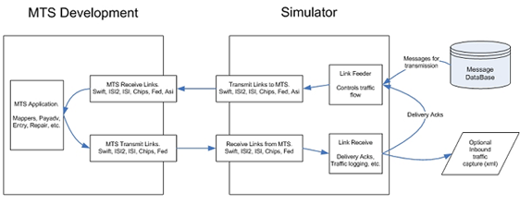

# Simulator UI

## Main Menu Page Functions

This is an initial screen that is shown after the connection to the simulator is made.

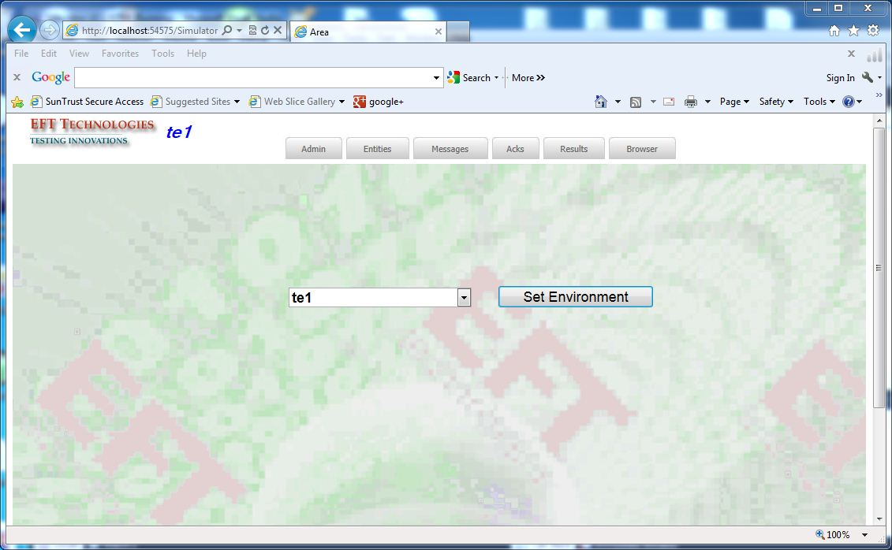

Choosing the Admin dropdown gives this screen:

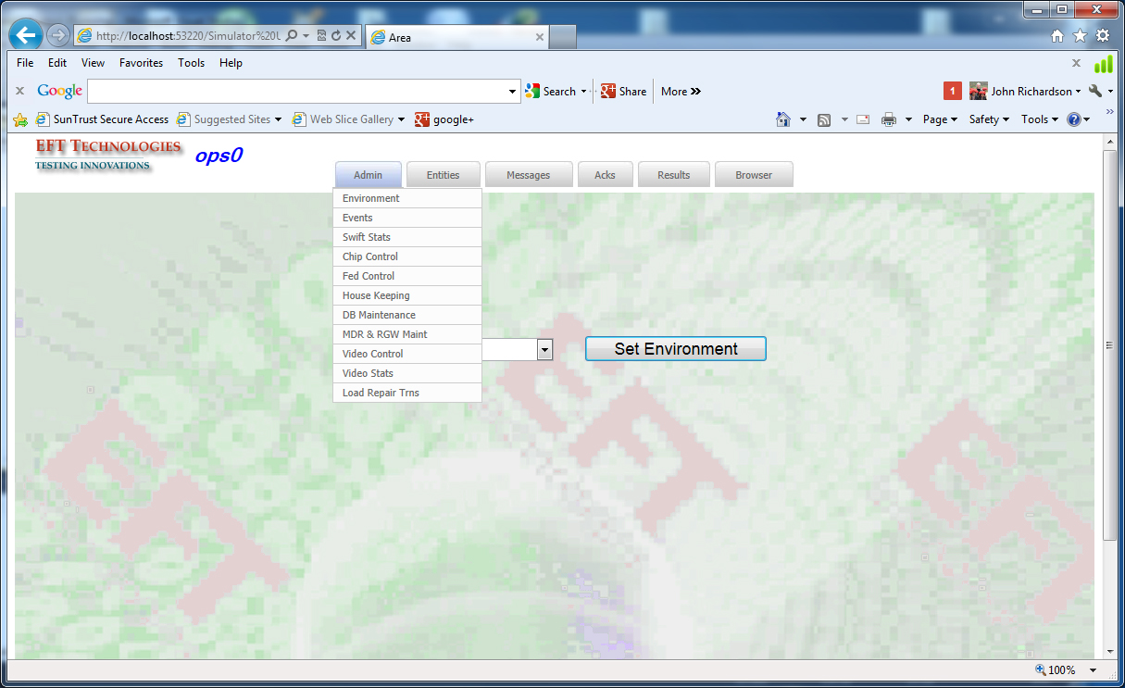

### Administrative Functions:

|  |  |
| --- | --- |
| Environment | Selects an AREA of testing |
| Events | Shows all systems’ events |
| SwfStats | Shows message counts of the Swift Interfaces |
| ChipsControl | Sets various Chips parameters |
| VideoControl | Sets various parameters to control Video sessions |
| Video Stats | Shows counts of entered/repaired/verified messages |
| Housekeeping | Variety of maintenance utilities |
| MDR & RGW Maint | Utilities for RGW & **M**aster **D**ata **R**epository related functions |
| Video Control | Controls video parameters for replay. |
| Load Repair Trns | Loads data for auto repair. |

The Entities drop down shows this screen:

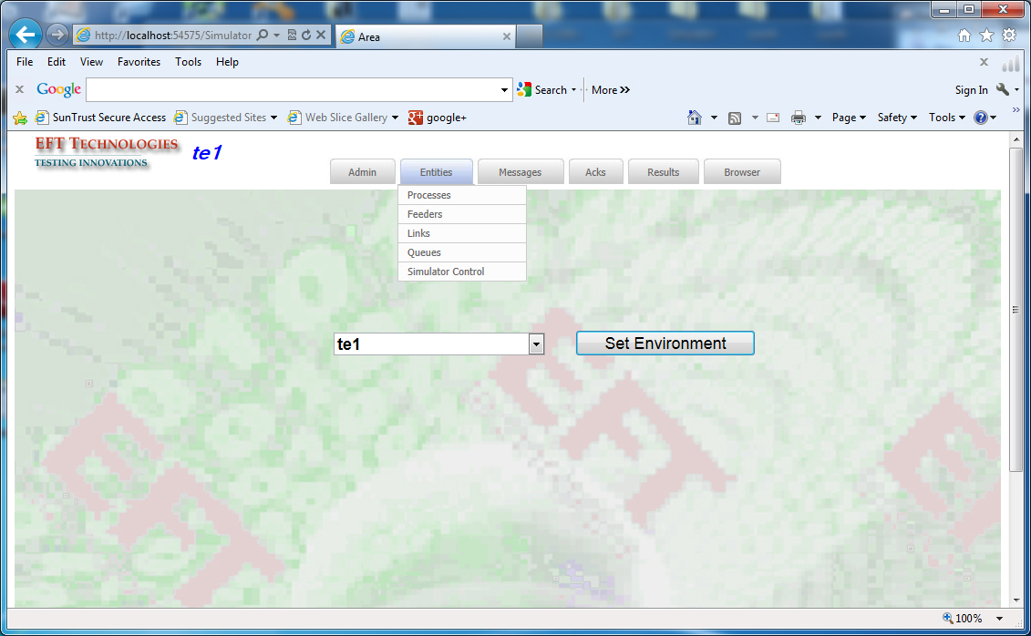

### Entities Functions:

|  |  |
| --- | --- |
| Process | Controls Processes in the selected Area |
| Feeder | Controls Timely Delivery |
| Links | Controls communication ports for configured links |
| Queues | Shows Queue counts for messages to be processed |
| Simulator Control | Show or edit the Simulator Control Table |

The Messages drop down shows this screen:

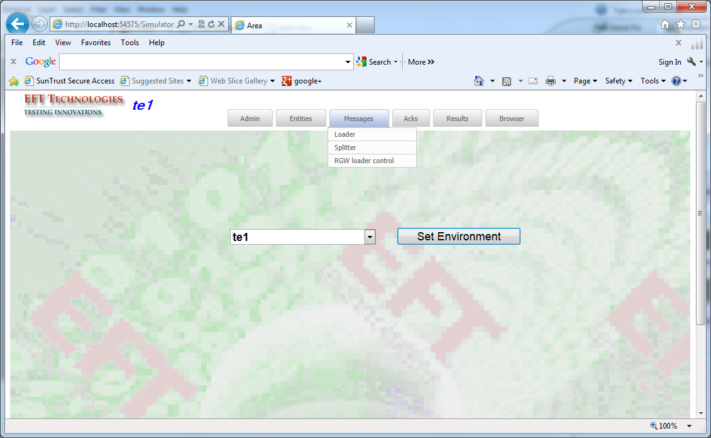

### Messages Functions:

|  |  |
| --- | --- |
| Loader | Assigns prepared structured file for processing |
| Splitter | Splits IDI or MsgUtil files into internal file structure |
| RGW Loader Control | Controls loading of RGW LOAD files into the database. |

### Acks Functions

The Acks drop down shows this screen:

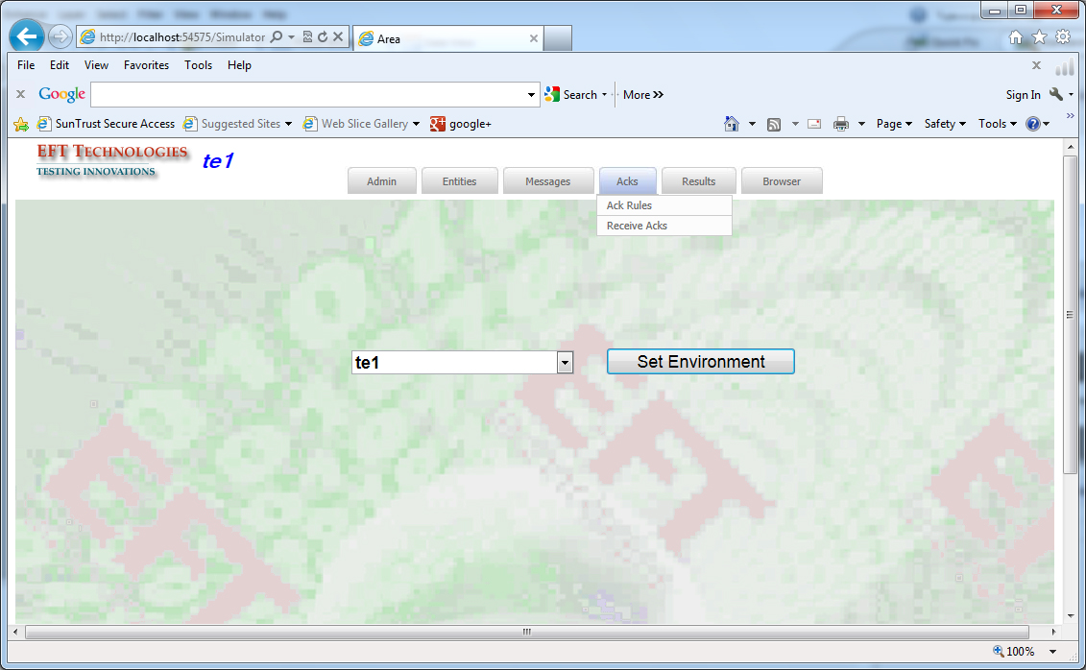

Acks Functions:

|  |  |
| --- | --- |
| AckRuleTable | Sets up the rules for naking SWF/CHP/FED messages |
| RcvAcks | Controls the flow of received messages by the Simulator |

#### Results Functions

The Results drop down shows this screen:

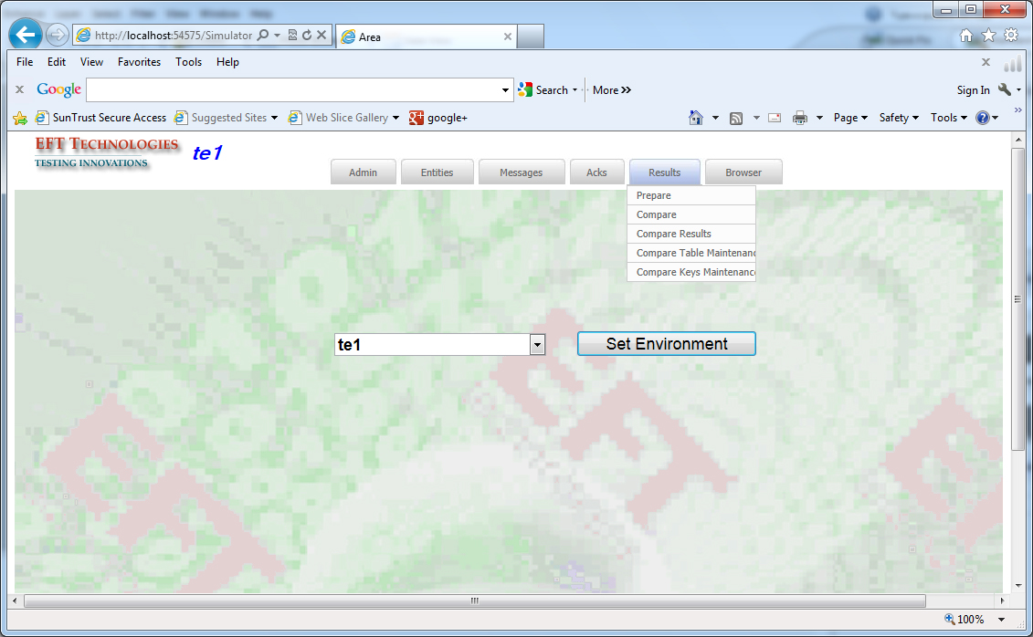

Results Functions:

|  |  |
| --- | --- |
| Prepare | Prepares a file of IDI formatted messages for comparison |
| Compare | Compares two files and produces the difference list |
| Key Maintenance | Maintains the table of the fields that are used for comparison of the results |
| Cmp Table Maintenance | Assigns files for comparison |

The Browser button shows this screen:

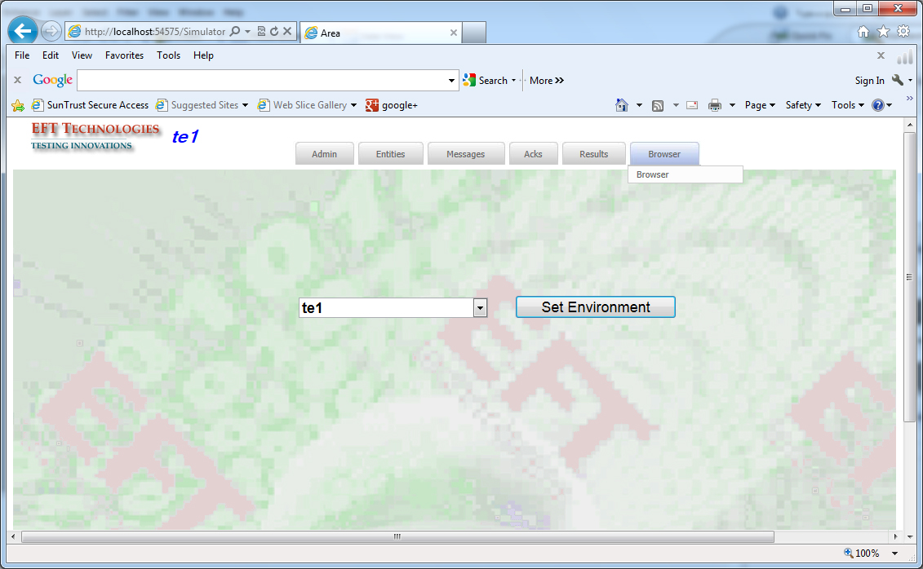

### Browser:

Browses MDR or RGW and allows to collect, compare or replay fetched messages

## Administrative Functions

### Environment

The user can switch or select testing environment. All configured environments are listed in the dropdown box.

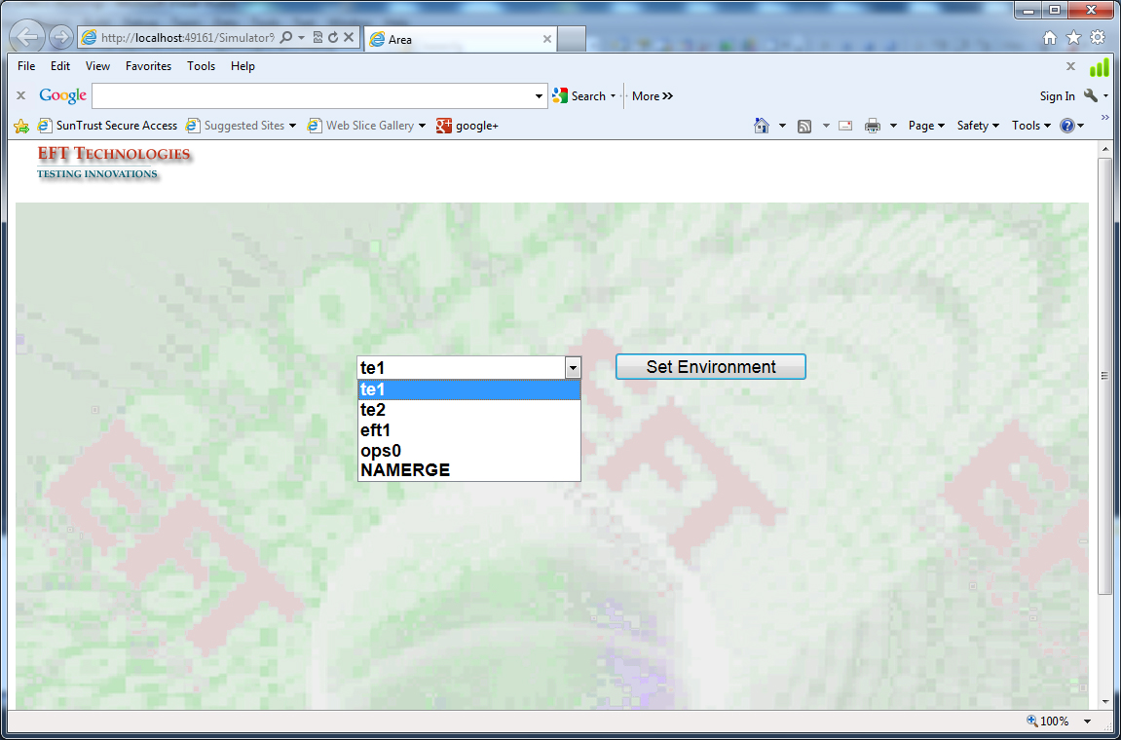

### Events

This shows all events activity as well as information about the Simulator. The user can sort the events by severity of error, the time of occurrence, and by process name.

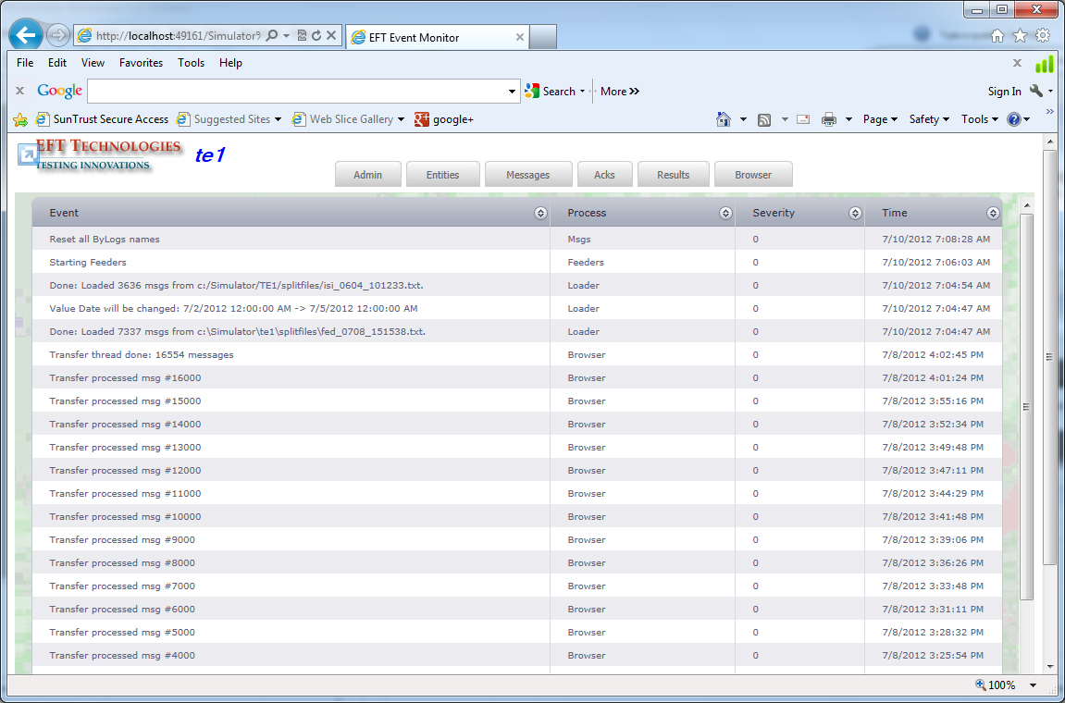

### Swift Statistics

This shows the activity thru all swift lines. The user can specify the time of the activity and/or the TID.

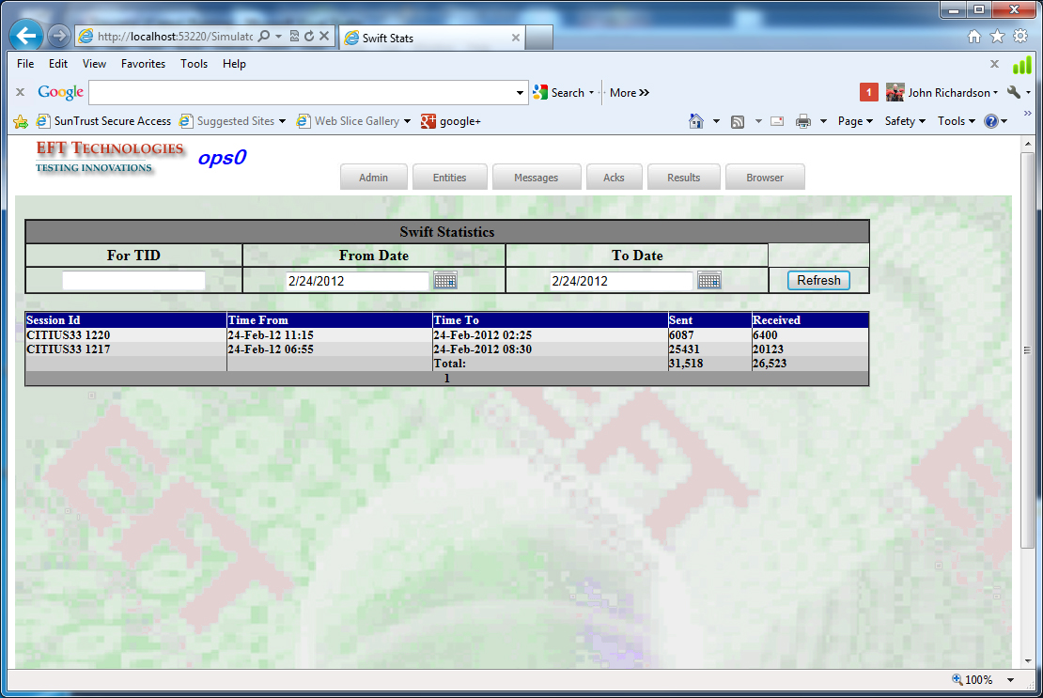

### Chips Control

It is used to set various Chips Parameters:

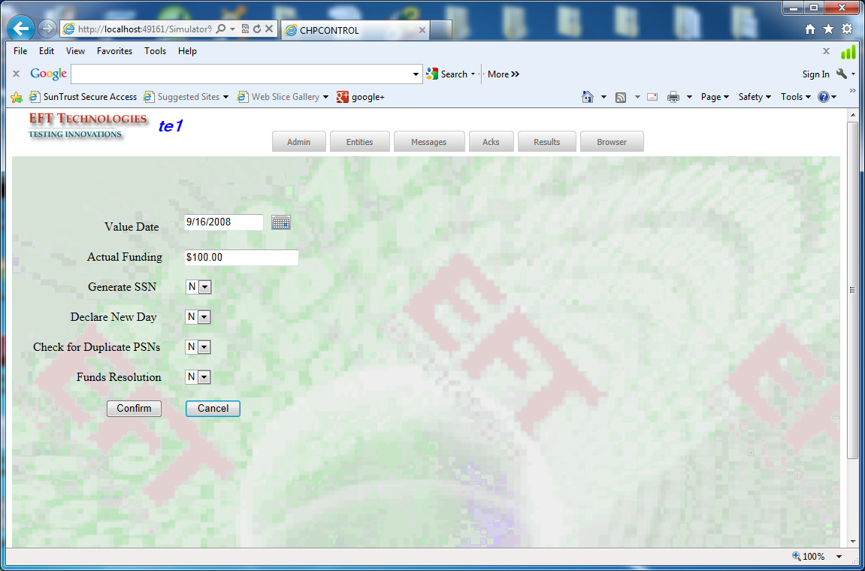

* Value Date:
* Current Processing Day
* Actual Funding:
* Generate SSN: allows keeping the original SSN intact
* Declare New Day: clears up all tables in preparation for New Processing Day
* Check for Duplicate PSN’s: allows duplicate processing
* Funds Resolution: controls whether to wait for funds to arrive before generating the Resolver message.

### Video Control

The user can change parameters for Video sessions. All values are in milliseconds.

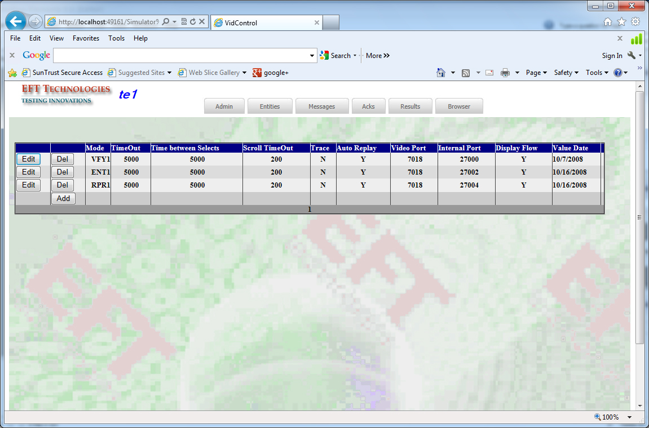

### Video Statistics

Shows how many messages were processed using Auto Repair/Verify module.

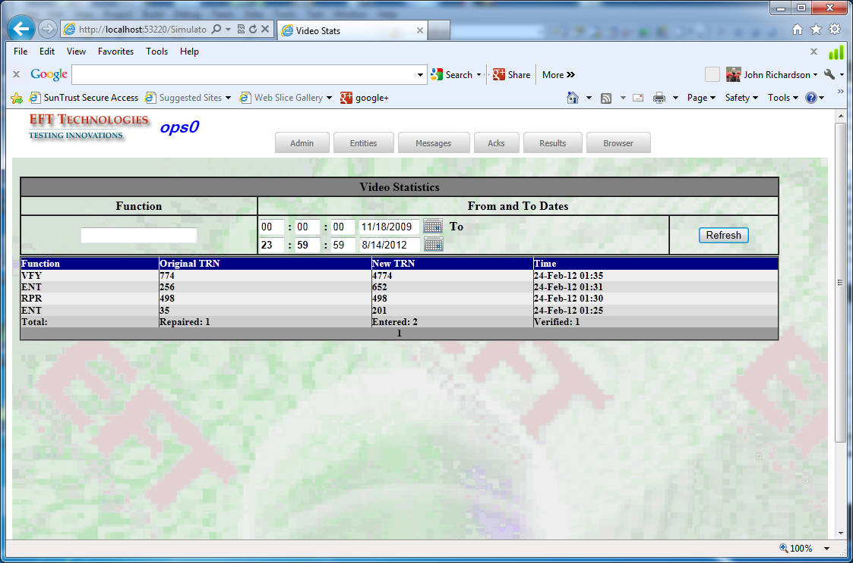

### Housekeeping Functions

All the available function to help maintaining tables, files. The user can change configuration values, maintain tables, and create new environment(s).

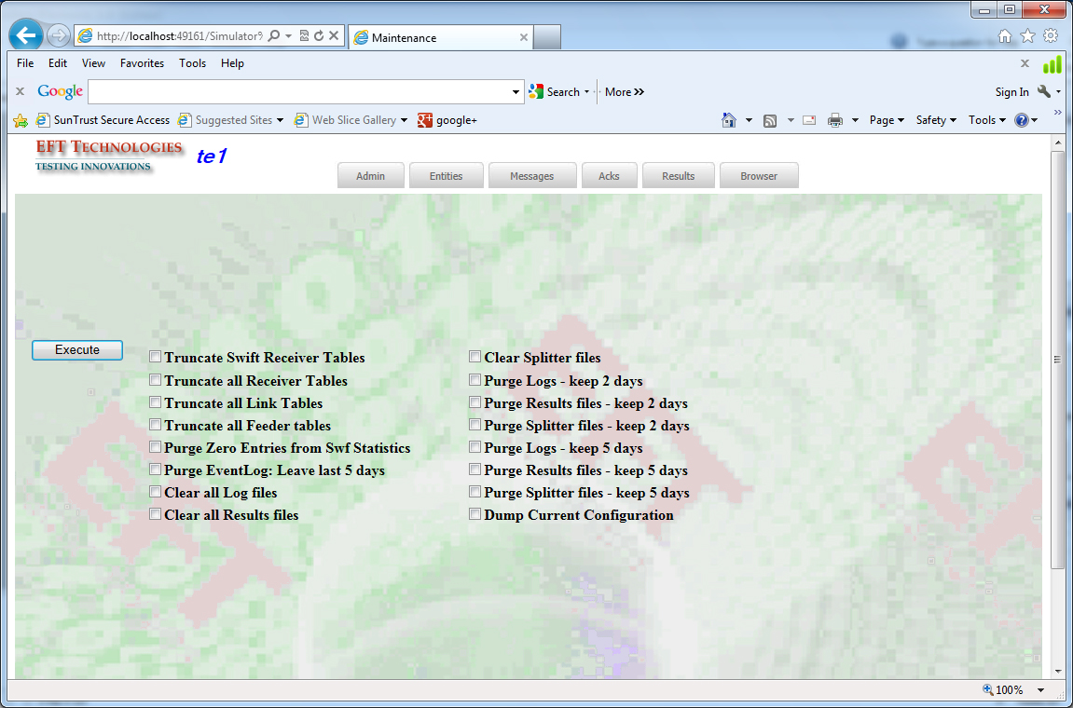

### MDR & RGW Maintenance

Housekeeping jobs for Loading RGW message files

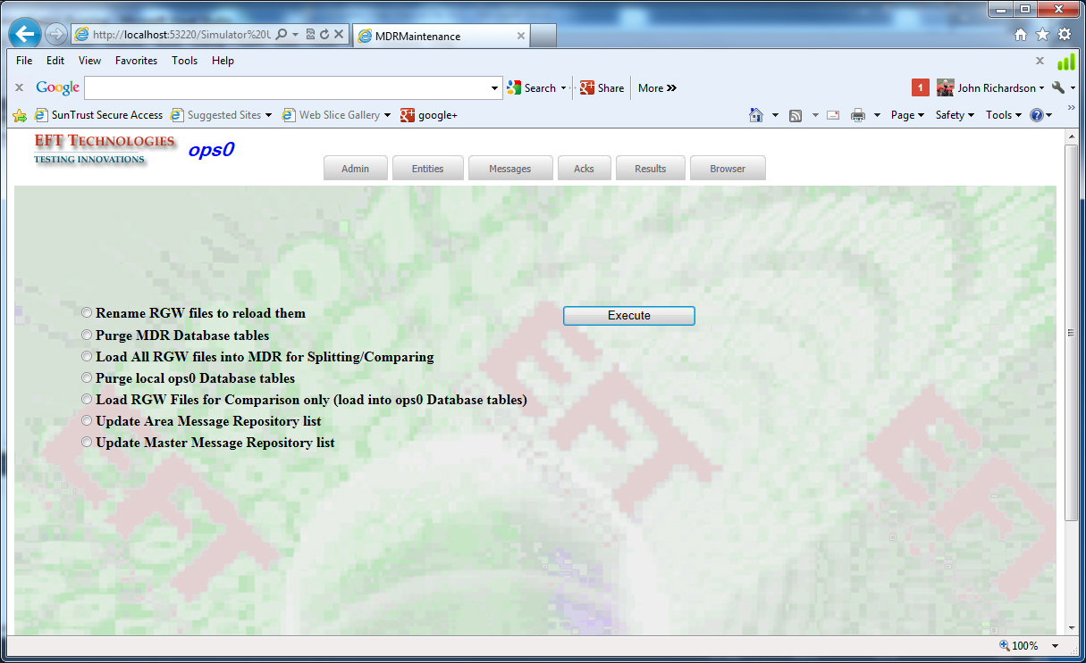

* Rename RGW files to reload them:
* Purge MDR database tables (Master Data Repository)
* Load All RGW Files into MDR for Splitting/Comparing
* Load RGW Files for Splitting Only
* Purge local <area-name> Database.
* Load RGW Files for Comparison only (load into <area-name> Database)
* Update Area Message Repository list
* Update Master Data Repository list.

## Entities

### Processes

This function shows and controls all configured processes for chosen environment. The users can stop/start a process or all processes. In order to start or stop an individual process, click on the select button to the left from the function name.

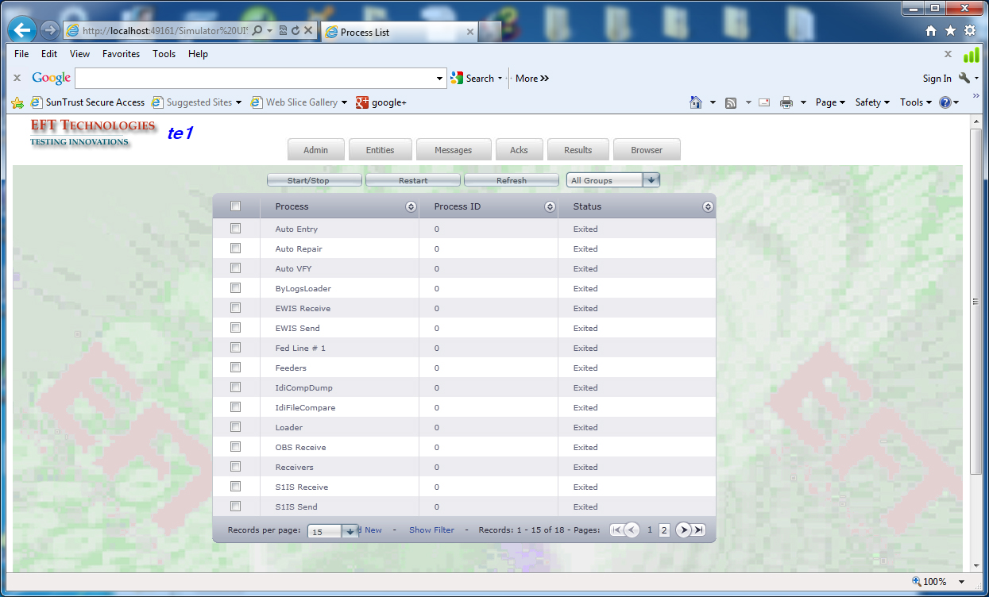

All active processes show the process Id. The processes are also grouped by functionality.

### Feeders

The Feeder formats the messages for transmission. It is responsible for combining messages into one transmission block if specified. The user has an option to choose Timely Delivery for the messages. That means that the Simulator will send messages to MTS at the exact time of original arrival on the MTS system. The application provides the time window for the timely deliveries. Within that specified time frame the timely delivery will take place. Outside of this time window the messages are delivered immediately. This option was developed to simulate the production environment. The time window is used to apply the timely delivery to testing time frame. If the test is conducted between 8am and 3 pm there is no need to restrict the delivery of the messages that originally arrived before 8 am or after 3 pm. Those messages are delivered immediately.

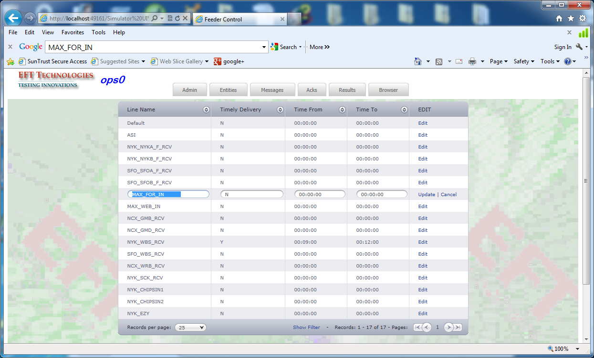

### Links

This function facilitates changing the assigned communication ports and sequence numbers for the configured links. You can add new links or delete old ones using this screen.

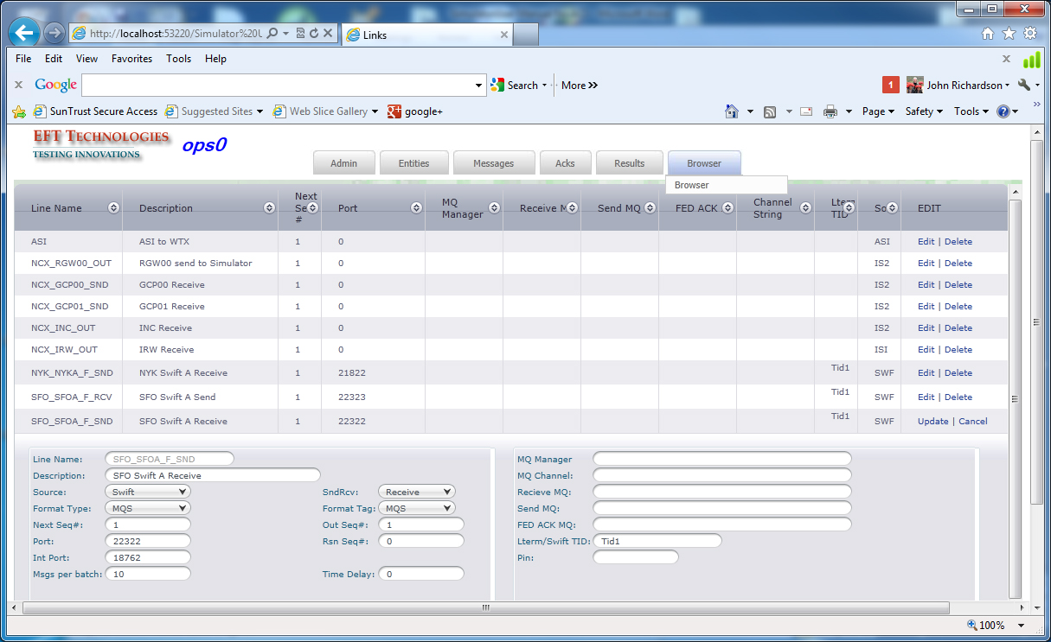

### Queues

This function shows lists of all queues with totals. For the feeder processes the user can select the queue to see more detailed information about items on the queue.

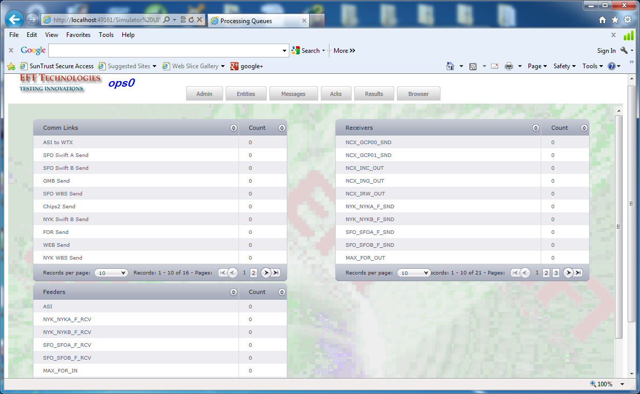

## Messages

### Splitter

This is a first step in the process of replaying messages via the Simulator back to MTS.

The user brings the file of IDI, MsgUtil, or ByLogs formatted messages to the local drive of the Simulator Server.

Using the Splitter function the user enters this file for processing. The splitter reads this file, creates internally formatted files and places them into the specified folder. The messages from the input file are segregated based upon the incoming line. They are written to the corresponding files that are named after the incoming lines.

Required fields in Splitter function:

Input file – the IDI or MsgUtil file from MTS

Optional fields:

Output folder: if omitted the default folder is /splitfile/ on the network drive. Upon the completion, the Splitter stages those messages for the Loader for processing. Those files are assigned with ‘W’ait state.

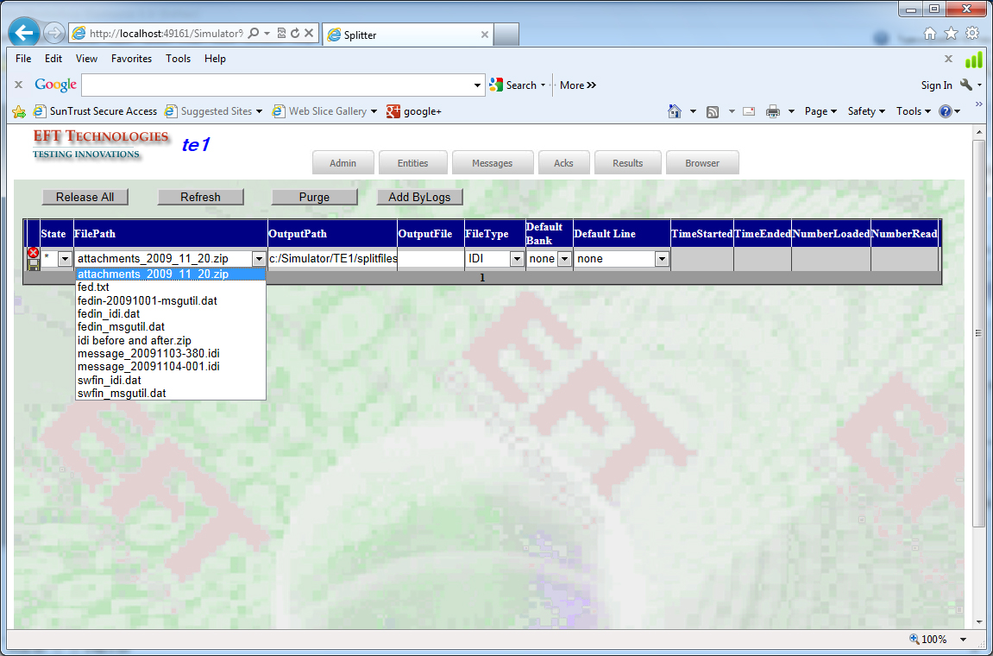

### Loader

The Loader processes the formatted files. It reads the assigned file and inserts the message into corresponding feeder table. You can globally change value dates, manipulate amounts, or assign new reference number values.

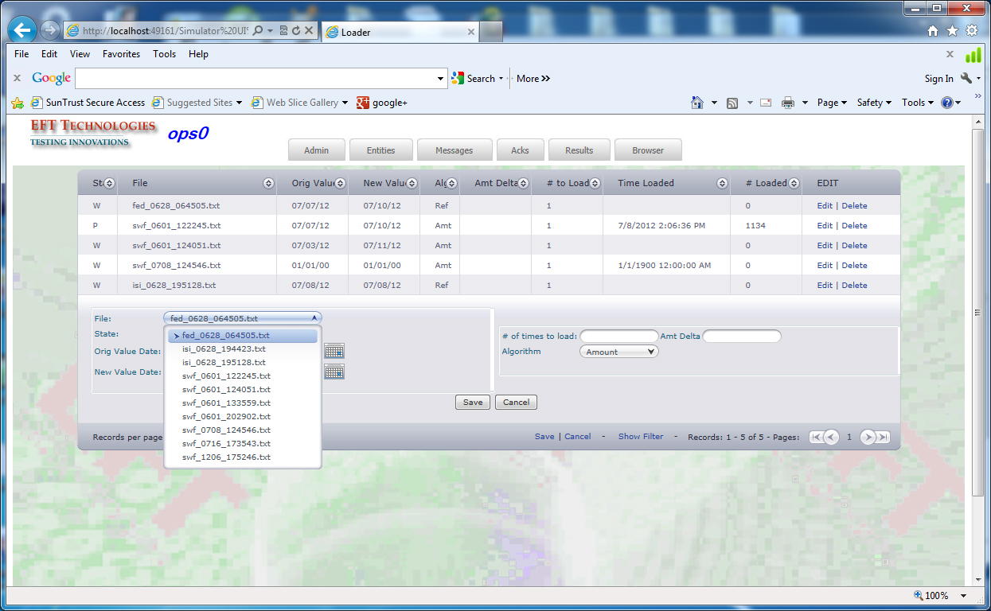

|  |  |
| --- | --- |
| Required fields | File with formatted messages |
| **Optional fields** |  |
| Nload | The number of times the files should be loaded |
| File Value Date | File value date to be changed to New value date |
| New Value Date | If these fields are entered the Simulator will advanced each value date by the number of days between the file VD and the new VD.  Thus, future valued messages are still going to be the futures during the test. |
| Algorithm | If nLoad > 1 this field specifies what Simulator needs to change to avoid PDMs on MTS. The options are Amt or SendRef.  If Amt is chosen 1c is added to the amount  If SendFef is specified a new SendRef is calculated using the system time.If nLoad > 1 this field specifies what Simulator needs to change to avoid PDMs on MTS.  If Amt is chosen 1c is added to the amount.  If SendFef is specified a new SendRef is calculated using the system time. |

Note: if the value date, amount or Sender Reference number is changed the simulator automatically changes {MAC to {TST to avoid authentication failures.

### RGW Loader Control

The RGW Loader Control allow the user to process RGW message files that are brought over from MTS system to be loaded into the MDR for replaying purposes or to the local environment for comparing purposes. The user can choose a file from the available list. It also provides information about the processing activities during the load. Typically, you will be loading the entire set of RGW files.

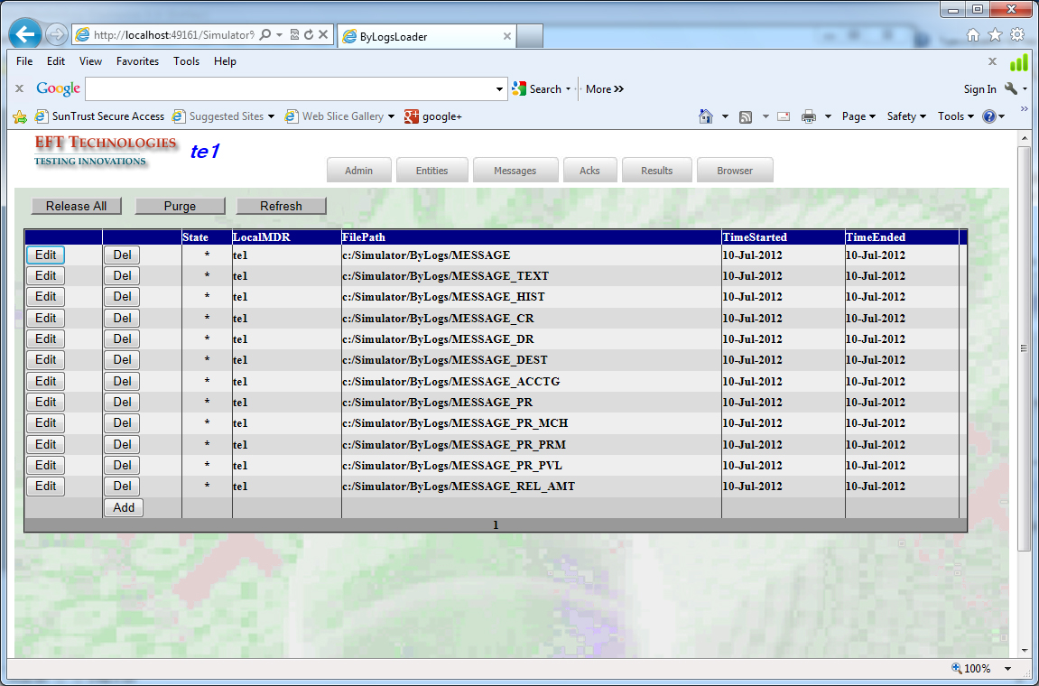

## Acks

### AckRuleTable Control

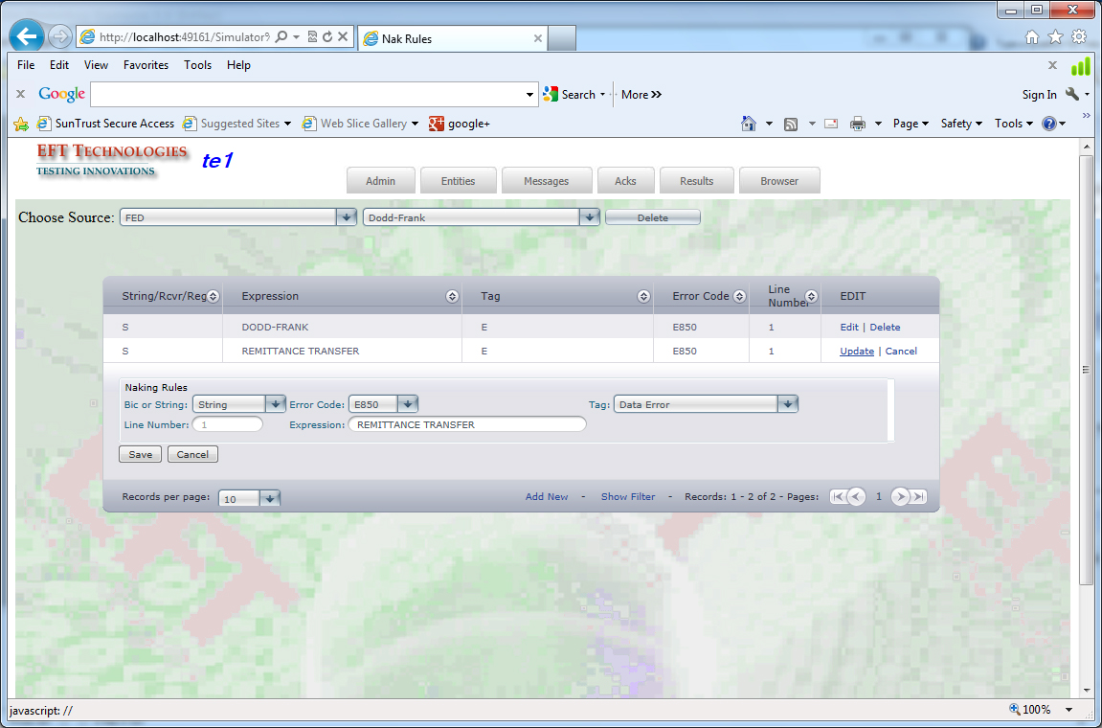

This table is used to control the Acking/Naking flow of the received Swift/Chips/FED messages. There are three basic options:

1. Nak by the receiver
2. Nak by presence of specified string
3. Specifying Regular Expression.

For all options the user can specify the error code and the line number for T-type of error code. If option 1 is selected all messages addressed to the specified receiver are Naked. If option 2 is selected each message is scanned for presence of the entered string and Naked if one is found. The third option applies the regular expression to the text of the message. The table name is assigned to the receiver line via ‘RcvAcks’ control.

### Ack/Receive Control

There are two types of receiving lines.

1. Lines that accept all traffic with protocol level acknowledgement.
2. Lines that can reject messages and require application level acknowledgement.

For the first category the user can only choose to output the received text into the file for further analysis.

The second category allows selectively choose messages for acking or naking. There are two ways to do that.

1. The receiving queue could be stopped; the user manually chooses messages for naking and than releases the receiving queue. The fact that the receiving queue is stopped is reflected in the Action window (lower part of the screen). The stopped queue precludes receiving of the new messages from MTS.
2. The user can assign the rule name table to the line (entered into AckRules control). Each message is automatically examined based on the information in the rule and processed accordingly.

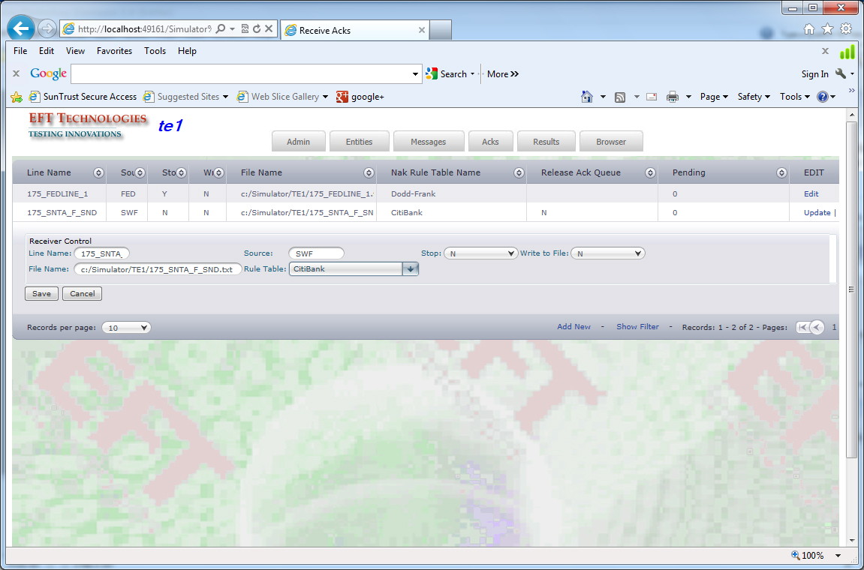

NOTE: If the AckRuleTable is assigned to the line the StopAckQueue option is disregarded. Messages are processed based on the table rules.

## Results

The test results are produced by comparison of the processed data - by comparing the ‘before’ and ‘after’ snapshots of the message data you can see exactly what has changed.

This can be done using RGW eod extract data or IDI dumps. In general, EFT recommends using RGW extract data for the following reasons:

* It is possible to be very granular about what traffic is replayed and compared. For example, you could choose all inbound Fed messages with advice type Swift over $100k which went to OFAC. IDI doesn’t give you this kind of flexibility.
* The RGW eod extract runs significantly faster than an IDI dump.

The basic comparison work flow is this:

* Load the ‘before’ snapshot into the simulator
* Replay the ‘before’ messages into your new code set.
* Extract the ‘after’ snapshot
* Load the ‘after’ snapshot into the simulator
* Optional – create or choose a specialized key table for comparison.
* Execute the compare operation which runs in the background.
* Analyze your results.
  + You can view the results in the Simulator UI.
  + The results are also written to csv and xml files if you with to load them into another database (such as Access) for further analysis.

### Load/Compare RGW Load files – EOD Extract

* Load the ‘before’ snapshot into the simulator
  + RGW message files are loaded via the ‘MDR & RGW Maint’ function
* Replay the ‘before’ messages into your new code set.
  + Use the Browser to select the messages you wish to replay. The Browser search criteria allows you to selectively choose data of interest – all messages that went to Ofac, for example.
  + One of the Browser choices is the name of the compare table – choose a table name that will make sense to you afterwards – “Ofac test 1 before”, for example.
  + Replay the traffic into MTS.
* Extract the ‘after’ snapshot
  + Run EOD on MTS and copy the RGW Message* files to the simulator
* Load the ‘after’ snapshot into the simulator
  + ‘MDR & RGW Maint’ function, again.
  + Use the Browser to select which traffic to compare.
    - In this case, choose your local area.
    - Select the traffic of interest – all the messages that went to Ofac, for example.
    - Choose a compare table name that makes sense – “Ofac test 1 after”, for example.
* Optional – create or choose a specialized key table for comparison.
* Execute the compare operation which runs in the background.
  + In this example, the two tables you want to compare are “Ofac test 1 before” and “Ofac test 1 after”.
* Analyze your results.

### Load/Compare IDI files

To load and compare IDI data you will need to do the following steps:

* Create an IDI dump of the traffic you wish to replay. Copy that to the Simulator machine – c:\Simulator|MsgData.
* Use the Splitter function to pull the message out of the IDI dump and queue them for replay into MTS.
* Use the Prepare function to load the initial message set into a compare table. Choose a compare table name that makes sense – “MTS 120819 Before”, for example.
* Replay the traffic into MTS.
* Create an IDI dump that contains the replayed messages. Copy that to the Simulator.
* Use Prepare to load the 2nd set of message into a compare table. Choose a compare table name that makes sense – “MTS 120819 After”, for example.
* Optional – create or choose a specialized key table for comparison.
* Execute the compare operation which runs in the background.
  + In this example, the two tables you want to compare are “Ofac test 1 before” and “Ofac test 1 after”.
* Analyze your results.

### Prepare

Use the Prepare option in Result menu, the user saves the results from the first test.

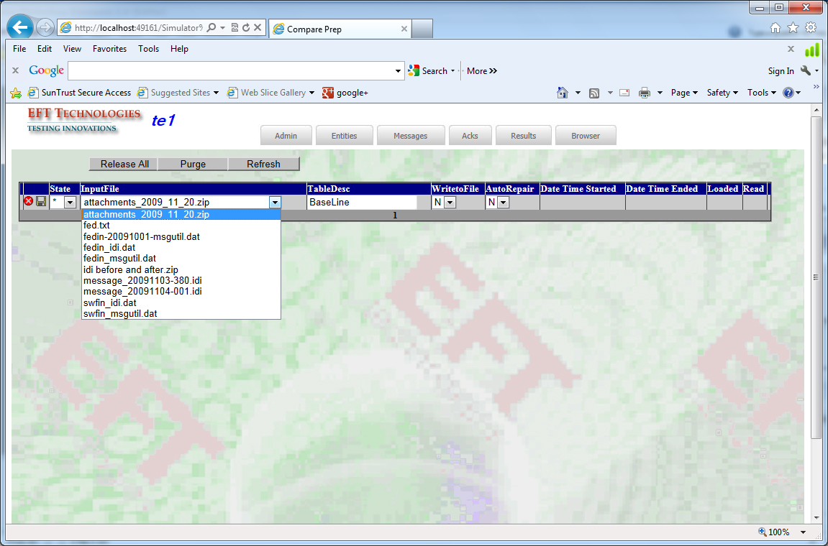

### Compare

After both test results are collected, the user is offered to change the list of the internal fields the comparison is done on. The user can exclude a field or a number of fields from comparison. It is done using CompKey Maint (Compare Key Maintenance). After that the user could start to compare.

The Compare step starts with choosing the tables to compare from the list of results tables. The user then selects the key table. It is a collection of the fields the compare process will use. The list of available Compare Key tables is presented. The user can change the key fields if needed.

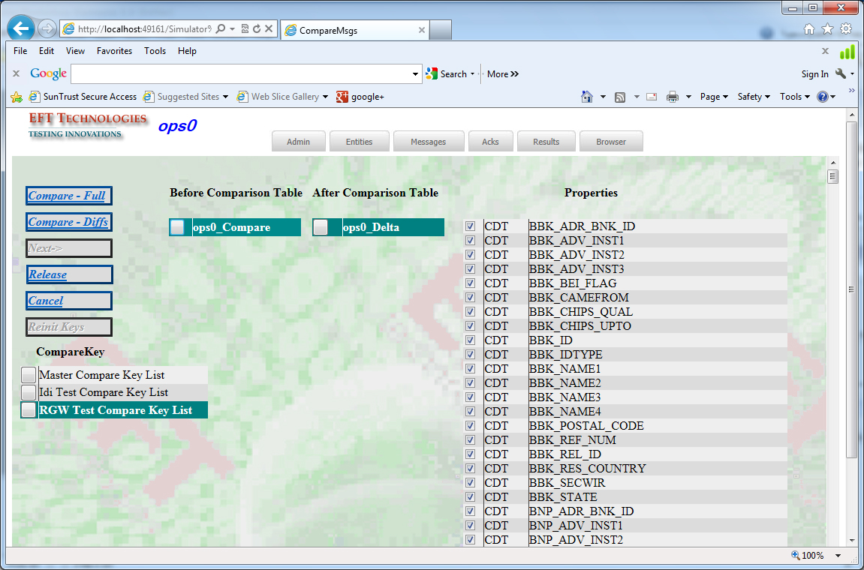

Click on ‘Compare’ button to start the compare process. The Simulator shows first 10 messages with differences. The user looks thru the list and can decide to exclude a certain field or a number of fields from the comparison process.

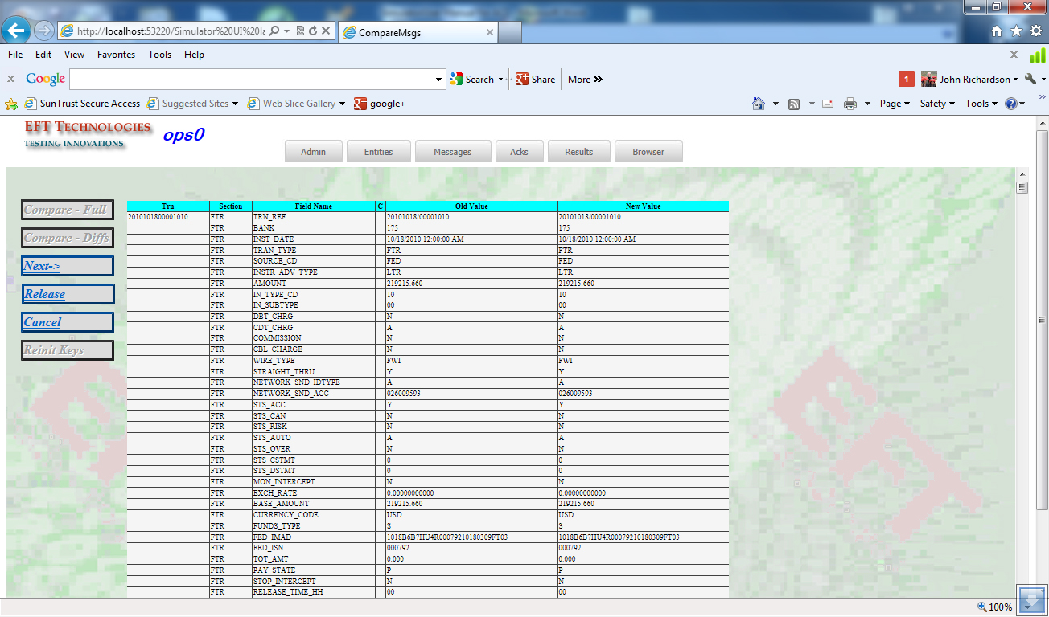

Click ‘Next’ to see next 10 messages.

After the user is satisfied with preliminary results, press ‘Release’ and the comparison step is submitted to run to the end. Currently the differences are stored in the database, in a comma-delimited flat file, in a flat file in XML format.. These files could be imported into excel, for example, for analysis.

### Cmp Table Maintenance

This allows the user to control the background processing. It is similar to ‘Loader’ table maintenance. The user can release a job, delete or restart this step.

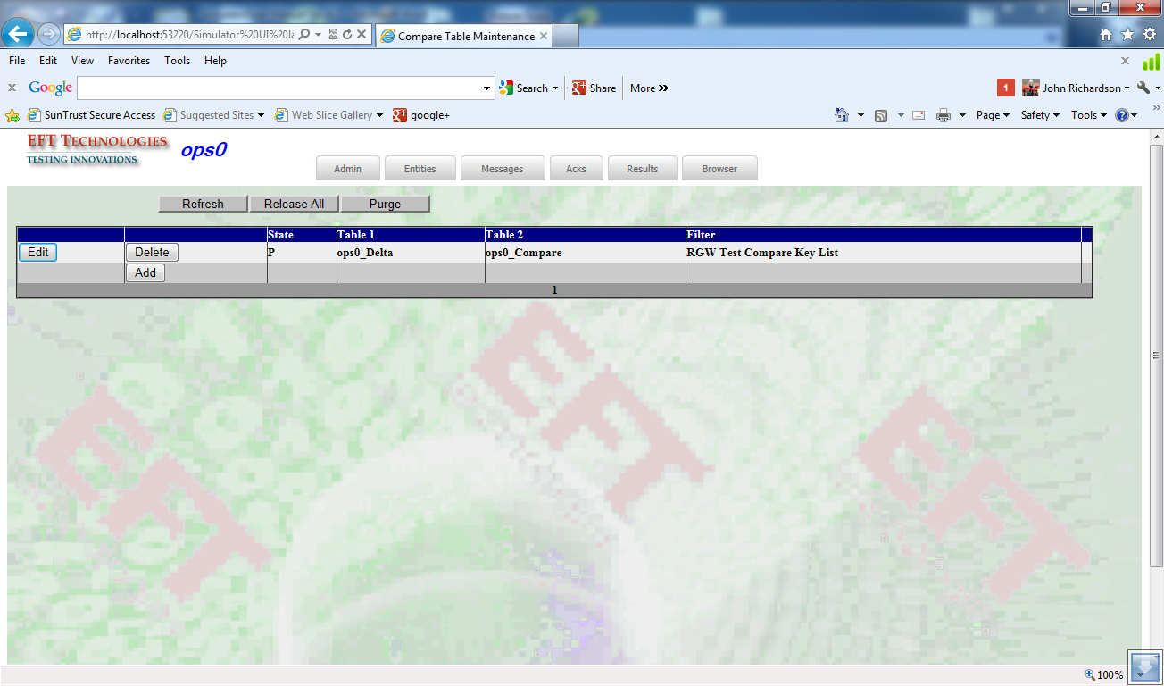

### Key Maintenance

This screen gives access to a number of functions regarding compare tables:

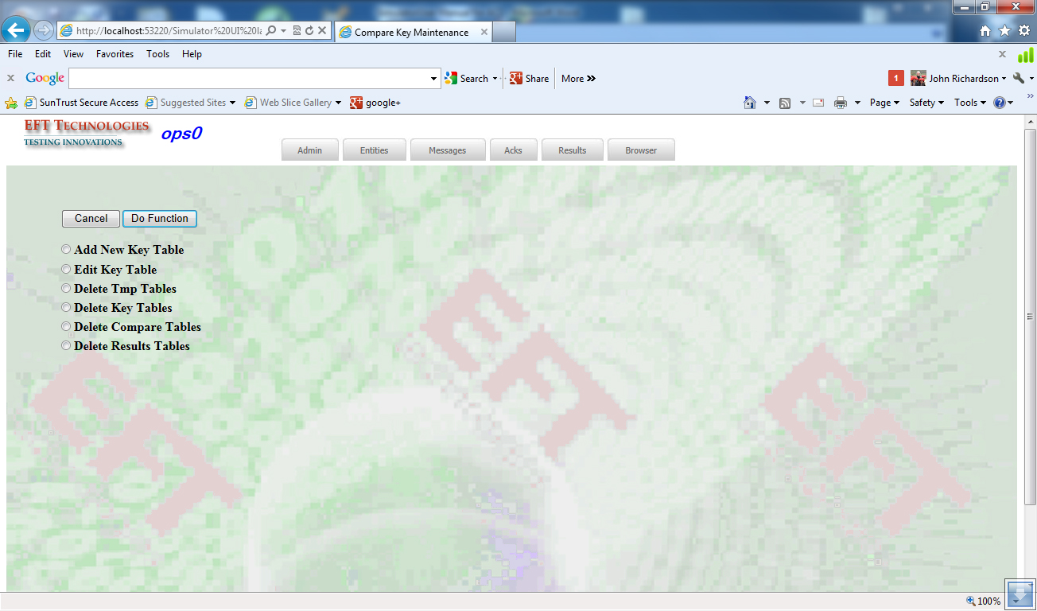

**Add New Key Table** - create a new key table from a copy of master rgw/idi key set.

**Edit Key Table** – edit an existing key table.

**Delete Tmp Tables** – housekeeping function.

**Delete Key Tables** – housekeeping to delete old key tables.

**Delete Compare Tables** – housekeeping to delete old compare tables.

**Delete Results Tables** – housekeeping to delete old results tables.

The first two functions allow the user to edit or create key tables that are used to choose the fields to compare. By defaults ALL the fields are being used.

For example, sometimes certain differences are expected. You can create a key table where those fields are unchecked and use that in your comparison. You may also want to create a key table that looks for differences only in the FTR set, for example.

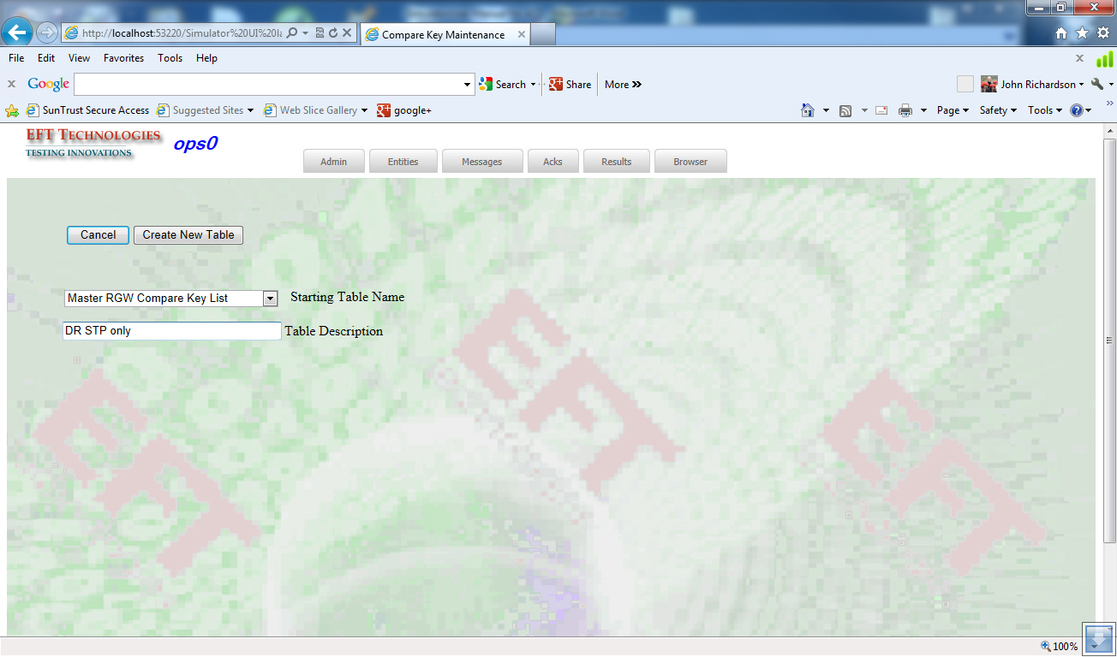

After you choose a table to create, you can edit the keys at that point. If you prefer, you can save the table and edit the keys at a later date.

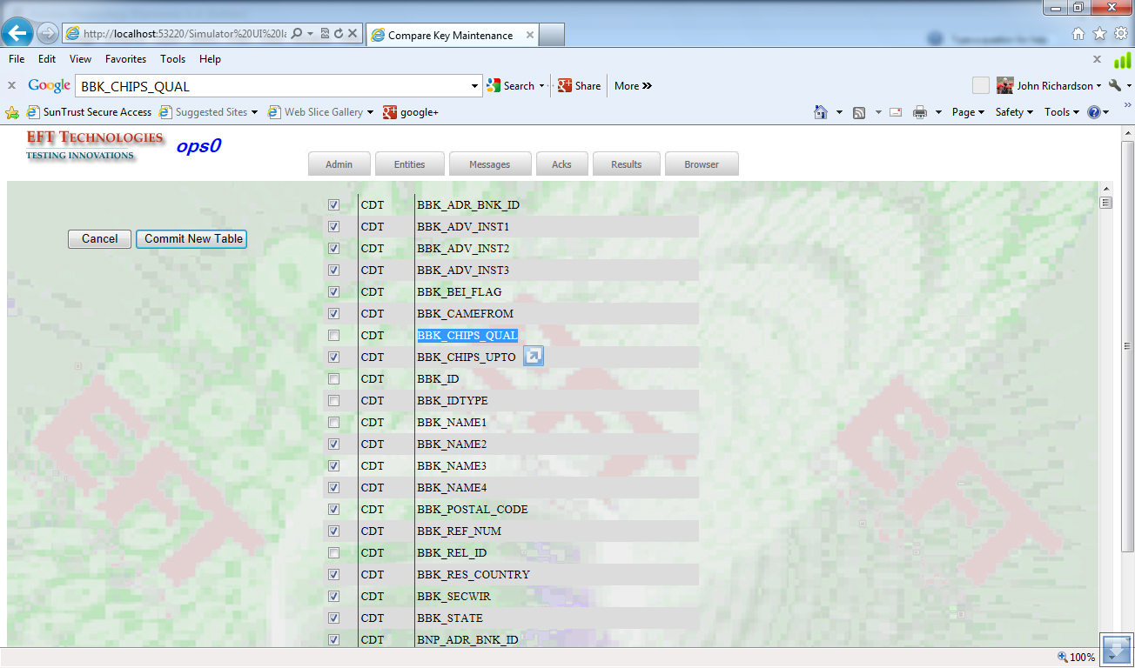

### Compare Results

After the Comparison job has run in the background, you can check the results. The top-most screen shows you a list of all the comparison jobs that have run in your area.

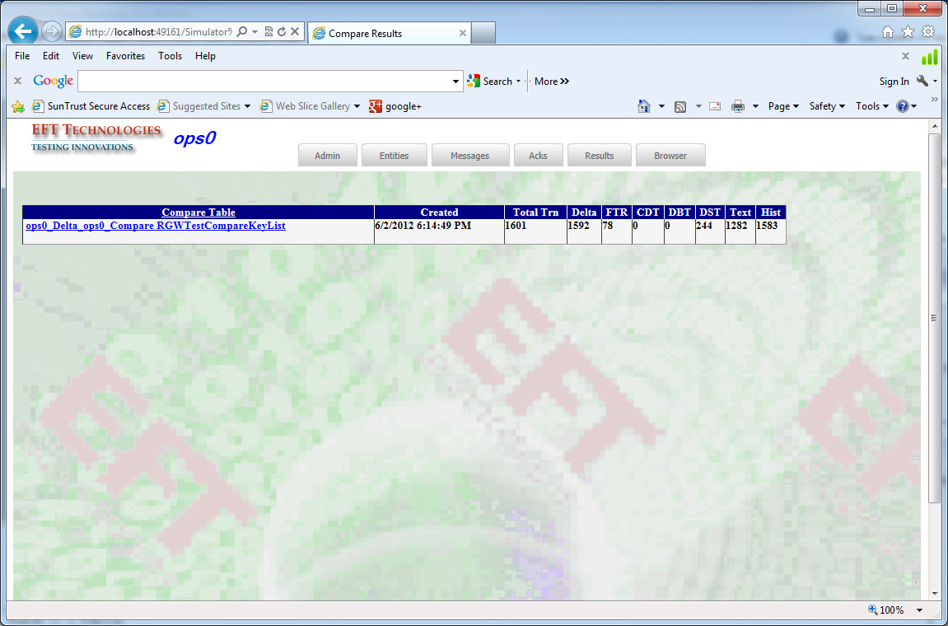

You can drill down into a particular run to see a meta-data summary:

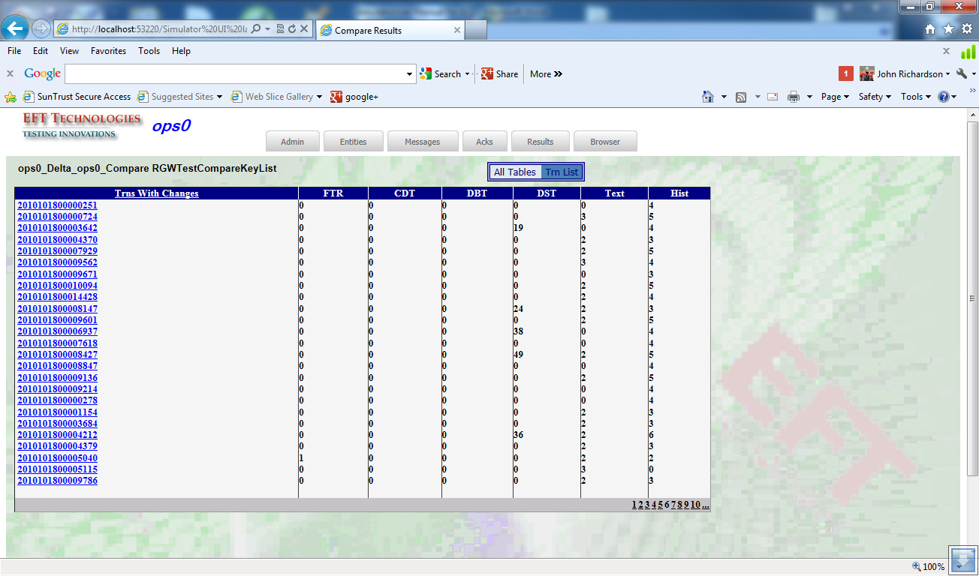

And from there you can drill down into an individual message. In that view you can see all the fields in the message or you can choose to see just the differences.

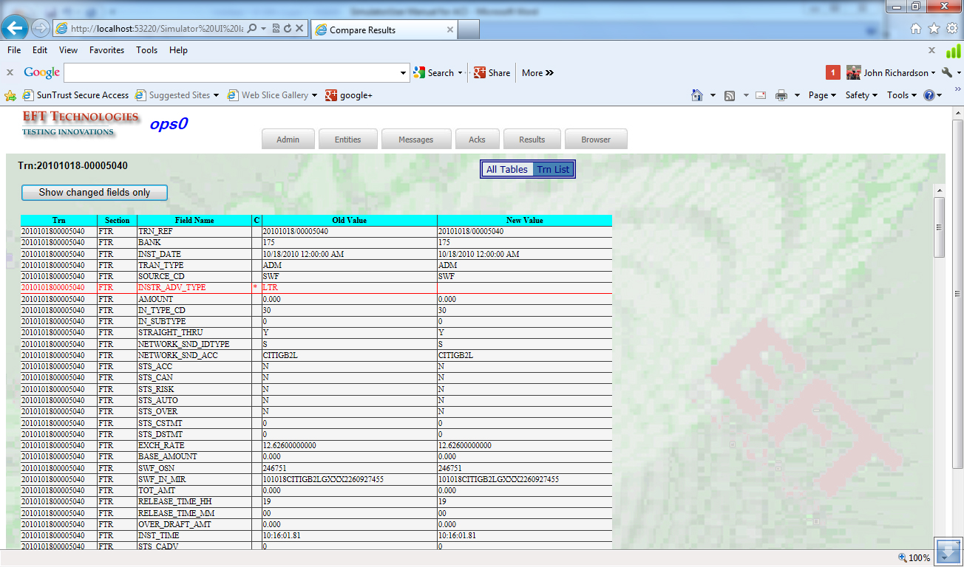

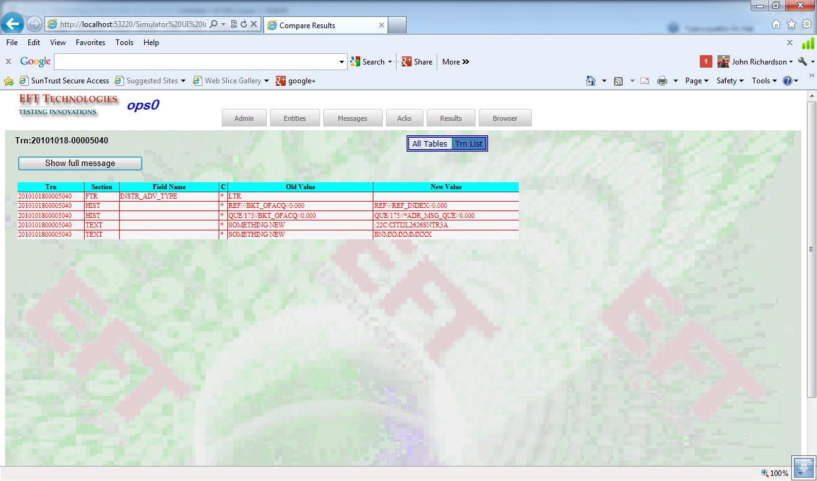

## Browser

It allows the user to search MDR (Message Data Repository) or RGW databases based on certain criteria and manipulate the set of results.

* **Search** – produces the list of transactions.
* **File Xfer only** – Extracts the list of selected messages into flat-ascii Loader files for future processing.
* **Load Compare only** – Loads the list of selected messages into the Compare Table you’ve chosen.
* **File Xfer & Load Compare** – Combines the above two functions: the selected messages are loaded into the Compare Table you’ve chosen and are written to flat-ascii Loader files at the same time.
* **Transfer Immediate** – Loads the list of selected messages into the Feeder for immediate processing.
* **Load Entry** – finds Data Entered transactions and loads them for processing.

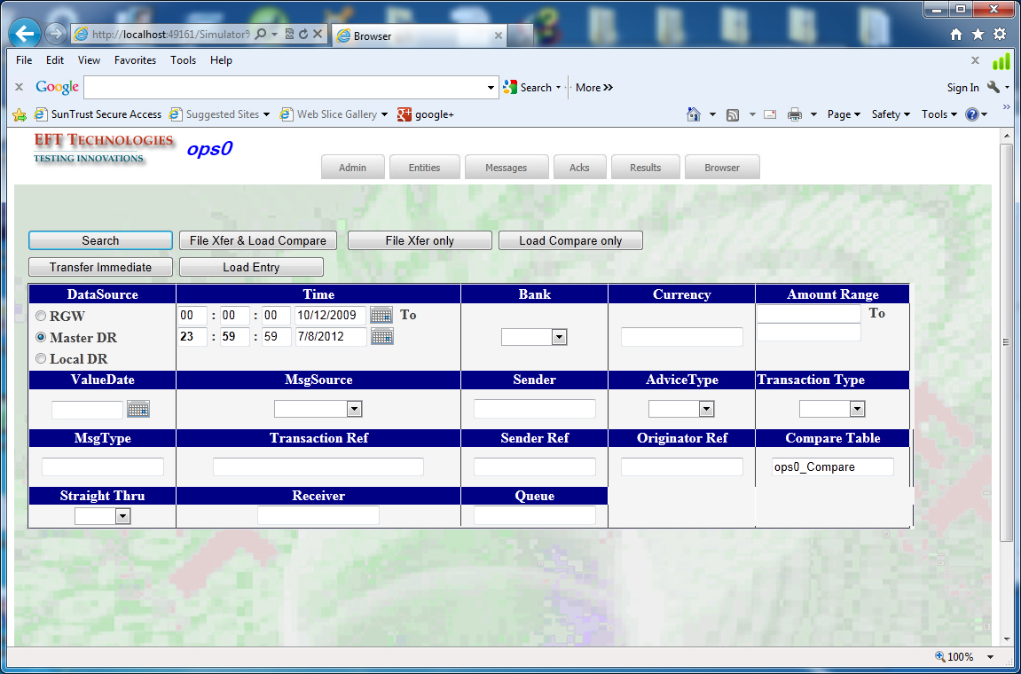

After entering selection, the list of found transactions is presented.

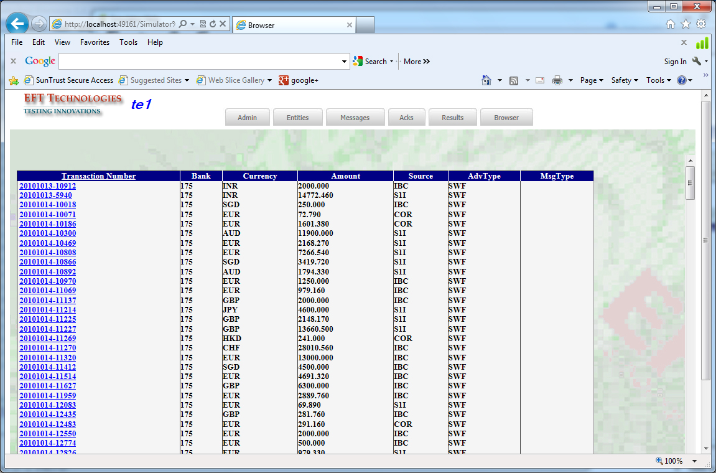

You can drill down into each transaction. Initially you come to the Summary.

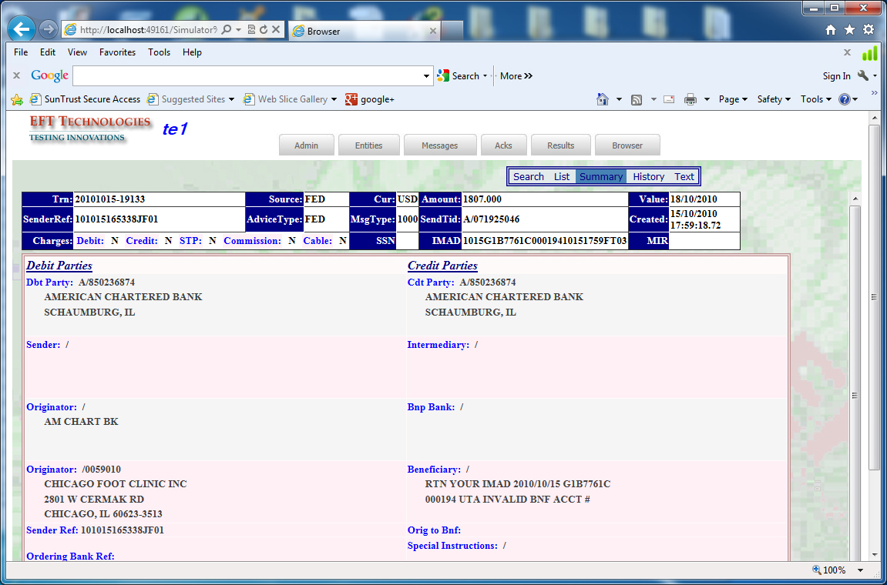

Choose History to see the message history:

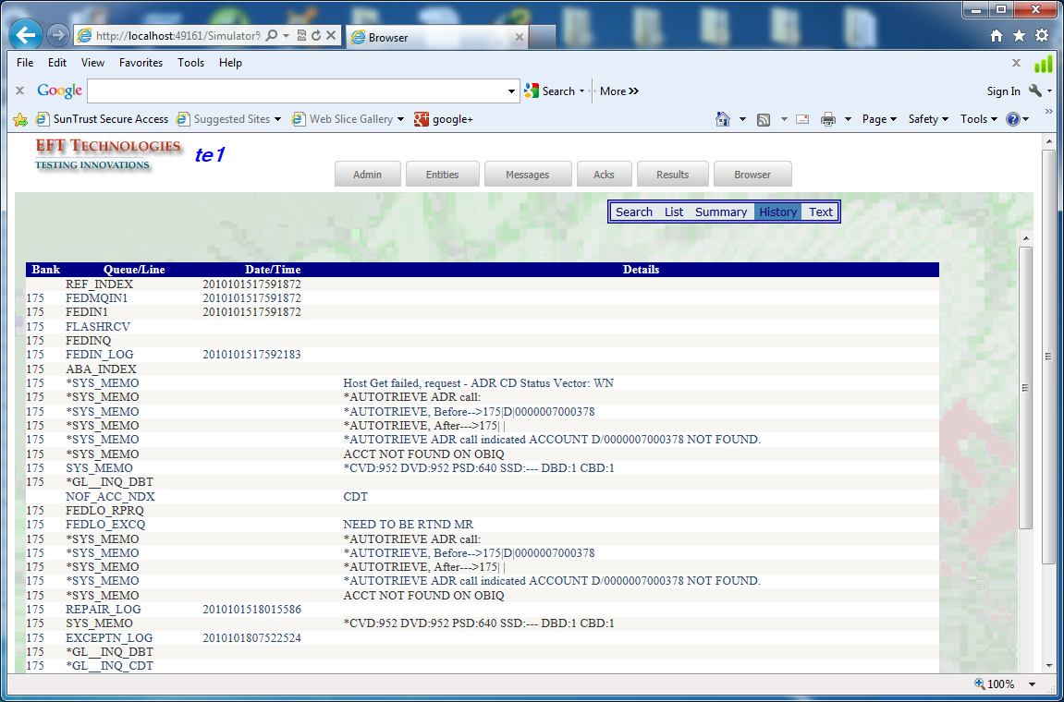

The text sequences. Input:

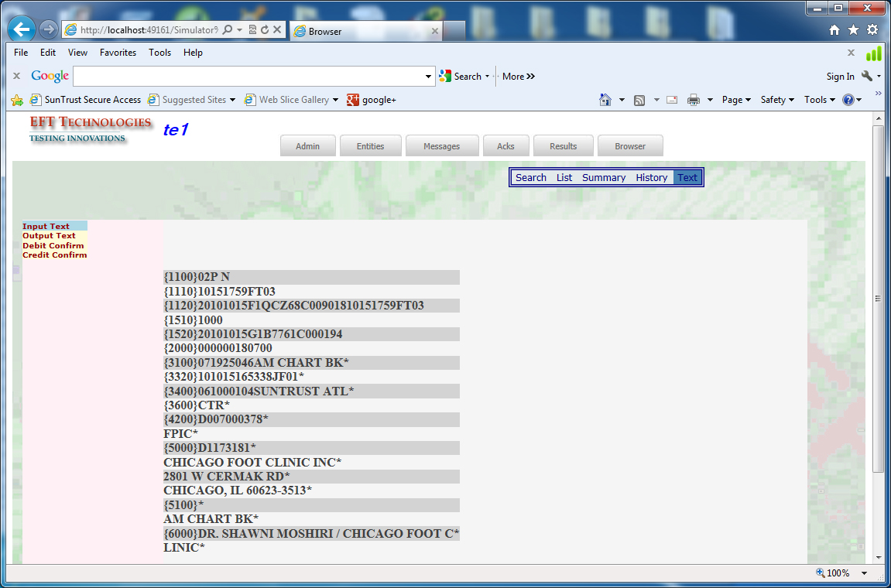

The text sequences. Output:

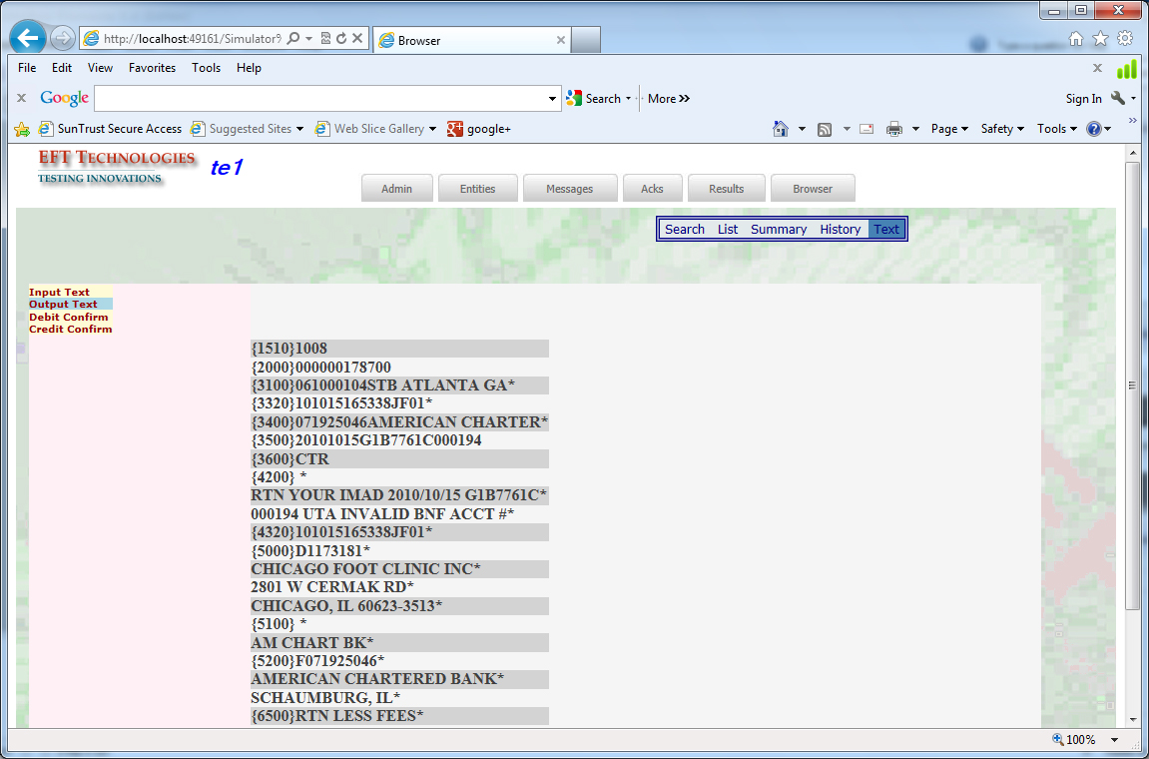

# Appendix

## Configuration Set Up

**ISI2 Links**

Certain parameters in the MTS remote record need changing to communicate with the Simulator:

PARAMETER_LIST:      "BATCH ACK COUNT/NOTHING_IS/0/10"  
PARAMETER_LIST:      "COMMIT MSG MAX/NOTHING_IS/0/10"  
PARAMETER_LIST:      "MAX PENDING ACK/NOTHING_IS/0/10"

The above need to be the same value and they need to agree with the NumberSel parameter in the LinkControl table on the simulator side.

PARAMETER_LIST:      "SESSION ID/NOTHING_IS/0/"

The above parameter needs to be empty/blank.

PARAMETER_LIST:      "ISI2 HEADER TYPE/ALPHANUMERIC_IS/40/V1"

The above one tells the link to user the version 1 header. The Simulator supports Version 1 and Version 2 headers. We suggest you use the version 1 header.

PARAMETER_LIST:      "TCP LOCAL HOST/NOTHING_IS/0/B001143578E31"  
PARAMETER_LIST:      "TCP LOCAL PORT/NOTHING_IS/0/23123"

TCP Local Host is the computer name or IP address of the simulator. The TCP Local Port is the port that will be used.